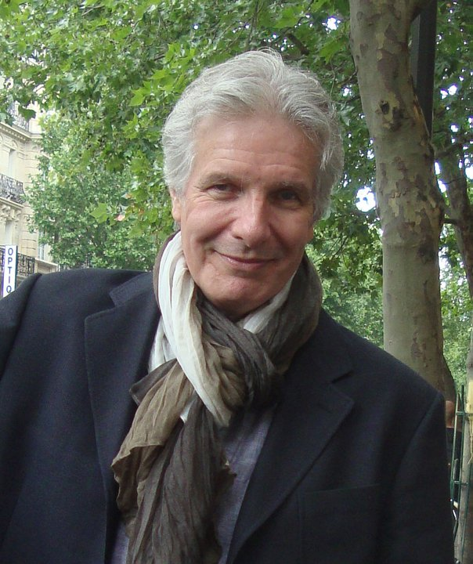

A former newspaper journalist and magazine writer, Ron Base has written for publications ranging from the Los Angeles Times, the Washington Post, and the Chicago Tribune to Cosmopolitan Magazine. For several years he was a columnist and wrote about movies for Canada’s Toronto Star, the country’s largest circulation newspaper.

He is also the author of a book about the history of movie stardom published several years ago in the U.S., Britain, and Canada called If The Other Guy Isn’t Jack Nicholson, I’ve Got The Part. He has also written a number of novels published in Canada, the U.S., and Britain.

Ron Base’s theatrically released features include First Degree (1995), a thriller, starring Rob Lowe and Leslie Hope; The Last Sign (2005), a supernatural thriller starring Andie MacDowell and Tim Roth; White Light (1990), a thriller starring Martin Kove.

He has also worked on film projects with film-making legends John Boorman and Roland Joffé.

Magic Man, a novel, was published by St. Martin’s Press of New York in August, 2006. The Strange, published by West-End Books of Toronto appeared in 2009.

In 2010, West-End Books introduced The Sanibel Sunset Detective, the first in a series of mystery novels set on Florida’s Sanibel Island, featuring private detective Tree Callister.

The second book in the series is titled The Sanibel Sunset Detective Returns. A third novel, Another Sanibel Sunset Detective, will be published in the fall of 2012.

Base was born and raised and educated in Canada. He currently resides outside Toronto with his wife, Kathy, and spends as much time as he can on Sanibel Island.

